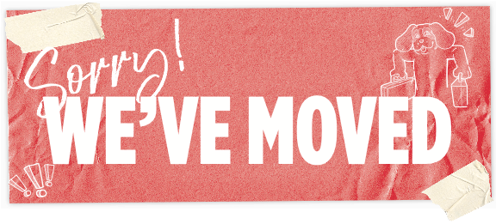

<INSERT NAME HERE>

HAS MOVED!

HERE’S THE NEW LOCATION

<INSERT LOCATION HERE>

